https://www.youtube.com/watch?v=mv8qJzyZggE&list=PLl4APkPHzsUXseJO1a03CtfRDzr2hivbD&index=12
Challenges managing docker containers manually
Container networking
Resource management
Security
High availability
Fault tolerance
Service discovery
Scalability
Load balancing
Orchestration

Kubernetes : Container orchestration

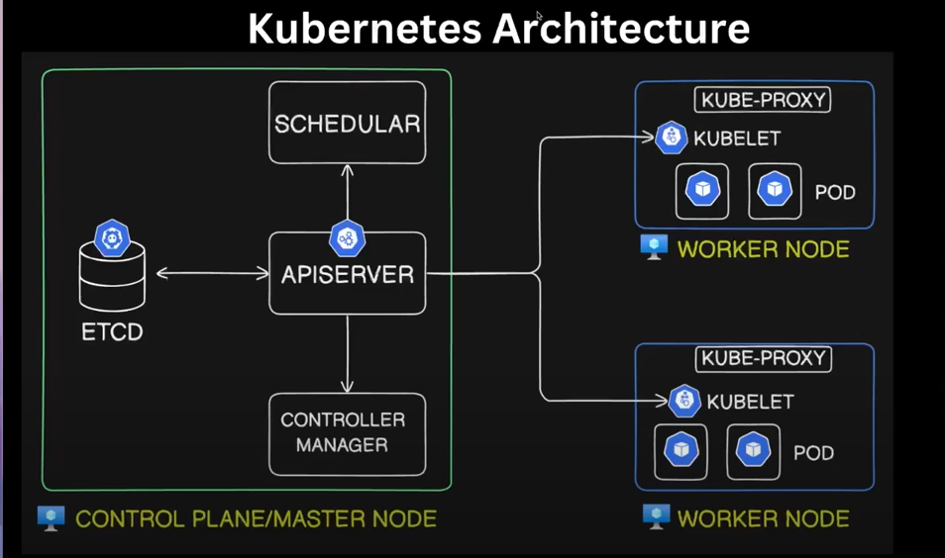

Worker node – runs your workload , contains pods (master node interacts with kubelet)
Control Plane/Master Node - Administrative and operation workloads are running
- API server : central service , which receives all requests with in service and outside (rest full API – kubectl convers into API call)
- Scheduler : schedules the POD on a particular instance
- Controller Manager : Desired state is maintained
- ETCD : key store data base , all the details of the cluster , operation , api calls , configuration

POD : smallest deployable unit , one or more container , ideally only one container , certain cases we might need side car container or init container , in that scenario , we might have more than one container

Kubelet : receives the command
Kube-proxy : connectivity and networking with in the pods are enabled

Deployment : collection of identical copy of POD , one goes down , provisions new container POD

Services in Kubernetes

- Cluster IP : services are internally accessible within the cluster
- Node port : exports certain ports within the cluster
- Load balancer : expose the service externally to the public internet

Azure cloud shell

az group create
az aks create
az acr create
az aks update
az sql server create
az sql db create

Install 2 extensions in Kubernetes – Replace Token , Kubernetes extension

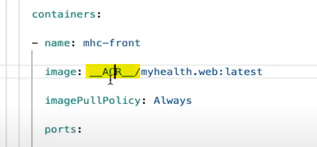

Image is tokenized in the kubernetes YAML file . We can replace token in the appsettings as well .
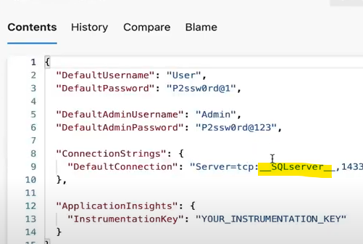

CI pipeline first two steps are replace token for the above two scenarios

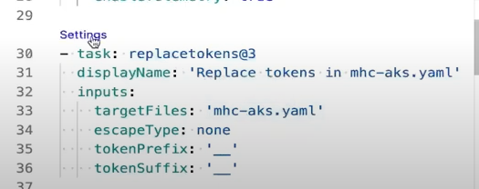

Actual steps in CI/CD pipeline below
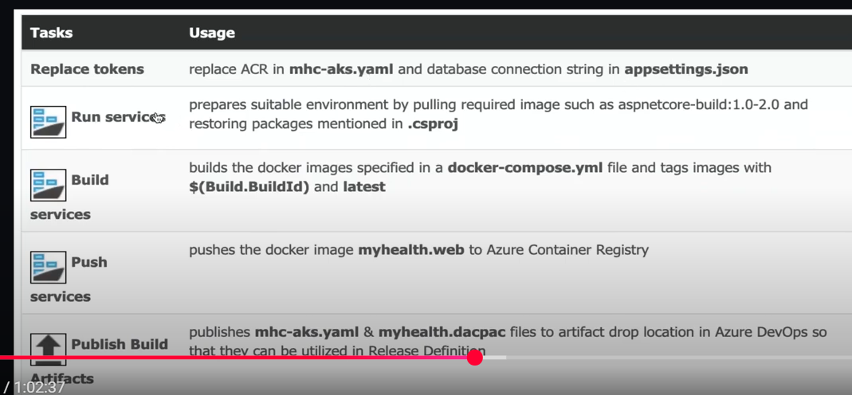

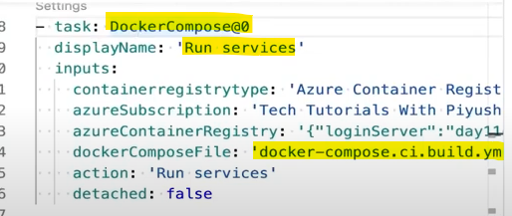

Docket compose : is used to define and run multi-container docker application . It contains configurations for : services , build configuration , volumes , networks , environment variables , depends on

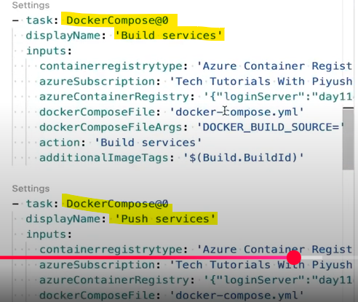

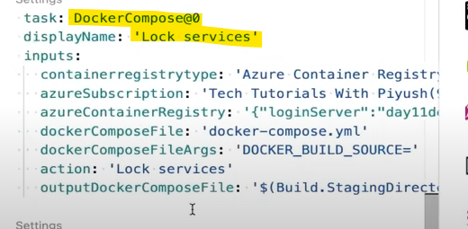

Above one creates a dedicated docker compose file which is used in release pipeline .
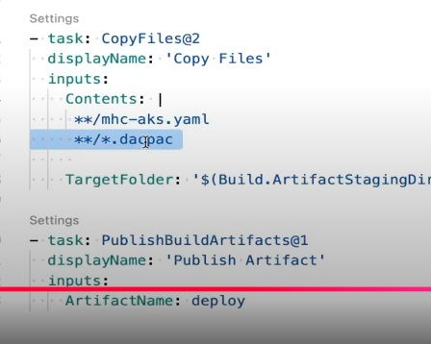

Build pipeline

Azure SQL Dacpac Task

